SECTION 3

1. What is a computer network? Explain its purpose in simple words.
A computer network is a group of two or more computers and devices that are connected together to share information, resources, and services like files, internet, or printers.
Purpose in simple words:
- To share resources like printers, files, and internet.
- To communicate easily with others using messages or emails.
- To save money and time by using shared resources instead of buying individually.

2. Write any three types of networks (based on size or coverage area) and explain each in one or two lines. (Example: LAN, MAN, WAN)
- LAN (Local Area Network)
  - Covers a small area like a home, office, or school.
  - Example: Computers in your classroom connected to the same router.
- MAN (Metropolitan Area Network)
  - Covers a city or town.
  - Example: A network connecting all branches of a bank in a city.
- WAN (Wide Area Network)
  - Covers a large area, even countries or the world.
  - Example: The internet is the largest WAN connecting millions of computers.

3. Draw and label any five network topologies. (Examples to draw: Bus, Star, Ring, Mesh, Hybrid)
a) Bus Topology
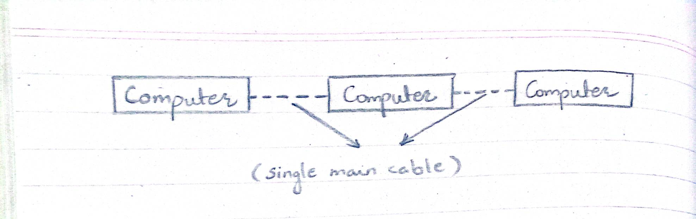
b) Star Topology
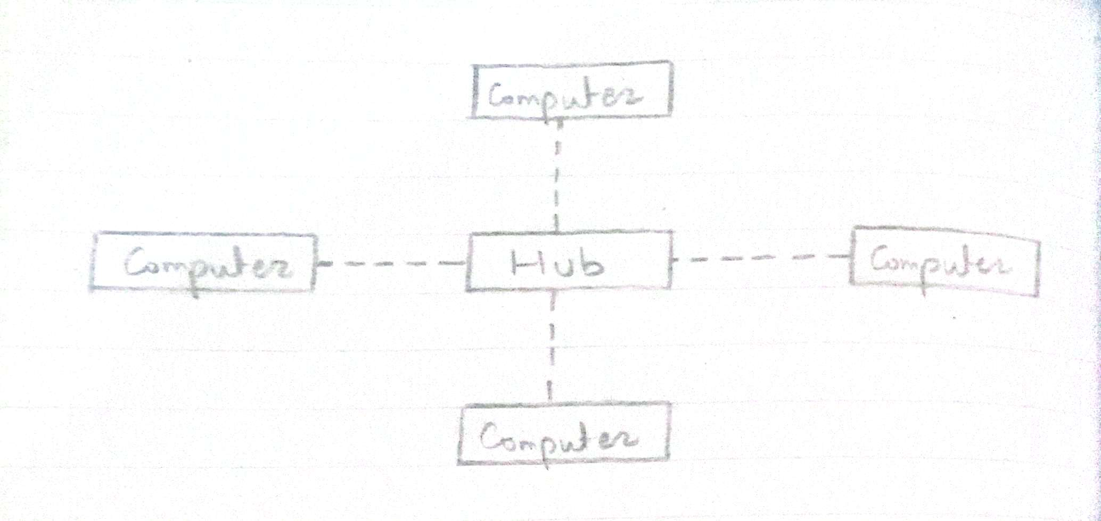
c) Ring Topology
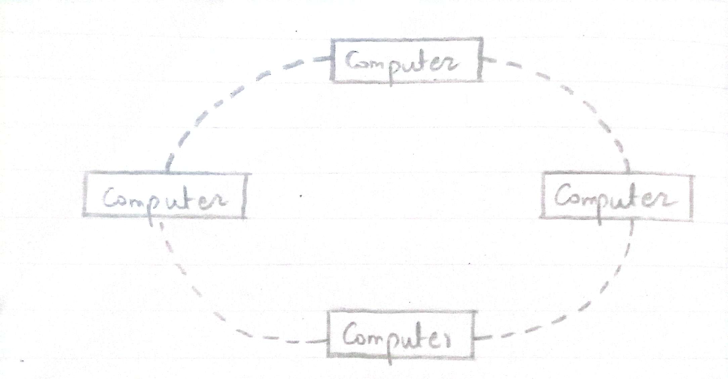
d) Mesh Topology
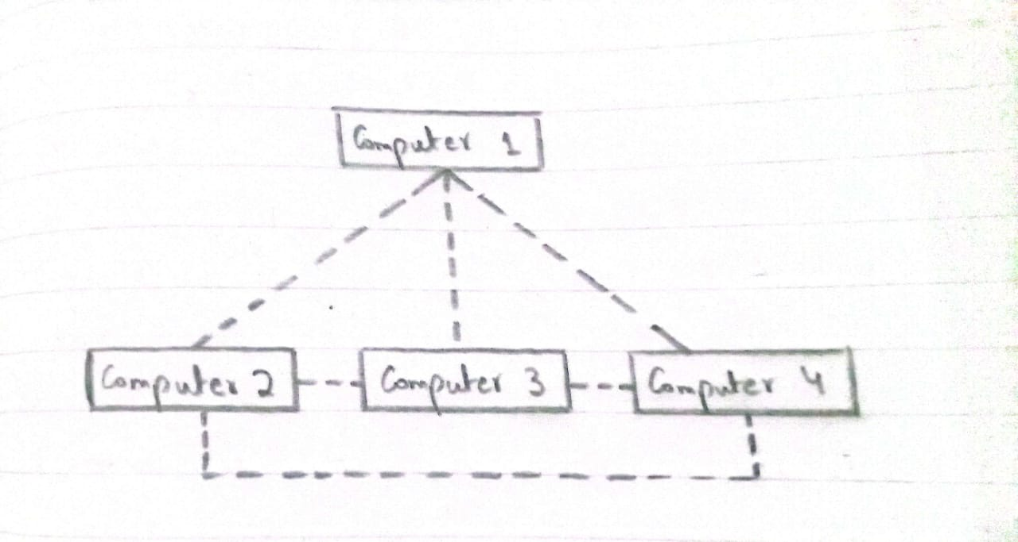
e) Hybrid Topology
